## Setup myPortal@work

1. Start myPortal@work
2. First time you start, you will be presented with a login page.  
   Enter the follow data:  
   User name – Provided by admin  
   Password – Provided by admin  
   Public IP Address:port – Provided by admin (x.x.x.x:8802)  
   LAN IP Address:Port – Provided by admin (x.x.x.x:8802)
3. Click Login.   
   By default, myPortal@work will control your desk phone
4. If you are working from home or don’t have a desk phone, you will need to do these  
   **VoIP Settings**  
   Click ***Your Name*** (to the right of )  
   Select: ***Settings***Select: ***VoIP***
5. Enable VoIP Enable 
6. Click on ***Advance ICE settings***
7. Just below ***STUN or TURN URI*** you will see some grey text  
   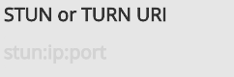  
   Click on the grey text and add: stun:stun1.l.google.com:3478
8. Click ***Add Server*** and the text you entered will appear grey
9. Click ***Check NAT type.*** You should get a message like this: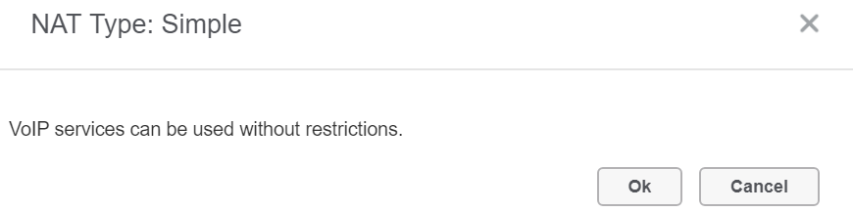  
   At this point, myPortal@work is ready to make/receive calls.

## Some settings that may help

1. Device settings   
   Click the device settings on the right, top toolbar   
   Using the standard PC speakers and PC microphone may not be ideal.  
   Here is a screenshot of a machine which has a Jabra USB headset.  
   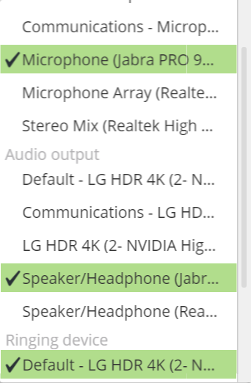  
   Here we have the Jabra Microphone selected  
     
     
     
     
     
   Here we have the Jabra Speaker selected  
     
     
   Is this case I have a different device for my ***Ringing device***  
   This means I can take the headset off and I won’t miss a call when someone rings.
2. Windows 10 Volume controls, right side of taskbar - 

When you click this icon, you will see the volume control for you default sound device  
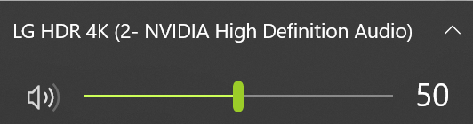  
That’s not doing any good, read on…

1. Click  (top right) and you will see the controls for all devices.  
   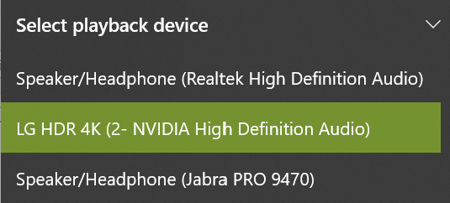
2. Now you can select the headset device and change the volume.
3. Once done go back and select the device you want as your default playback device