**Download OpenScape Mobile Pro Install from App Store**

<https://apps.apple.com/us/developer/unify-software-and-solutions-gmbh-co-kg/id302973846>



**Display the QR Code that contains your personal Account Information**

Once the app is installed, a different QR code is provided by Web Client or the UC Desktop App.

1. From Web Client or the Desktop App, click your name, then Profile  
   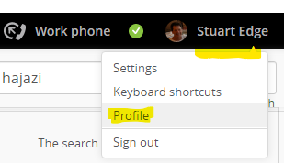
2. Click OS Mobile QR to display your QR code  
   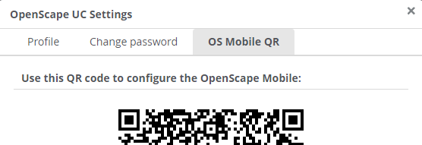

**Account**

Enter your account details in OpenScape Mobile as follows:

1. At the bottom of the screen, tap **More**  
   
2. Tap Settings  
   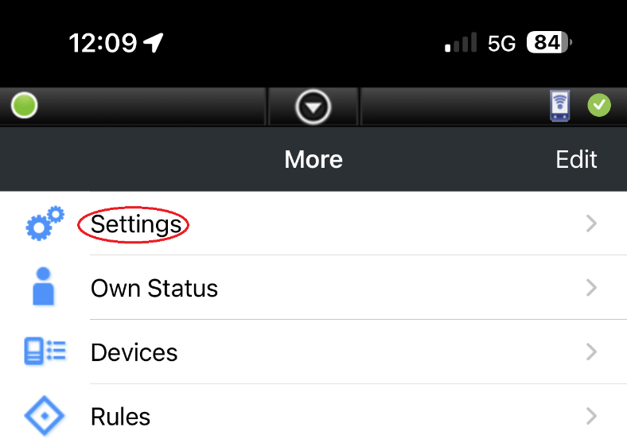
3. Tap Account  
   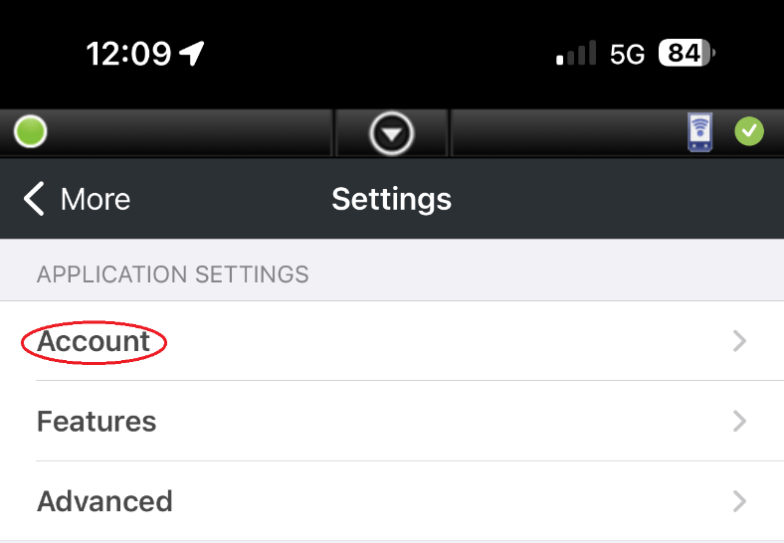
4. Tap the QR code Icon  
   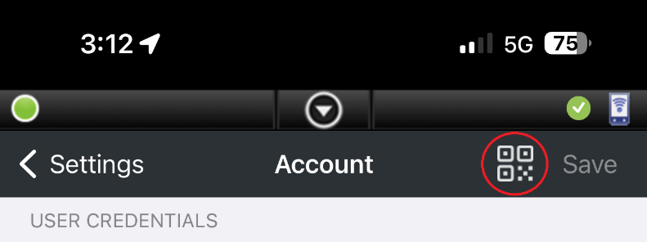
5. Scan the QR code.  
     
   You should get something like this, otherwise you can enter the details manually.

|  |  |
| --- | --- |
| Subscriber | user.name@system |
| Password | Manual entry |
| Remember me | Enabled |
| Cell Number | +6141111111111 |
| Server Address | <https://facade.olcs.com.au:8443/axis/services> |

1. Enter the password, it is not included for security reasons.   
   It is the same password you use to login to the Web Client or the UC Desktop App

**Recommended Settings**

1. Make these settings

|  |  |
| --- | --- |
| Allow VoIP Calls | Enabled |
| Route Calls to Cell | Enabled |

1. Advanced Settings

|  |  |
| --- | --- |
| Country Specific Tones | Singapore |
| Allow Invalid Certificates | Enabled |

**Login**

|  |  |
| --- | --- |
|  |  |